

(ISO 9001:2015 Certified), Accredited with ‘A’ Grade by NAAC

🕿: 08258 - 281039 – 281263, Fax: 08258 – 281265

**Department of Computer Science and Engineering**

B.E. CSE Program Accredited by NBA, New Delhi from 1-7-2018 to 30-6-2021

Report on Mini Project

Online Examination System

**Course Code: 17CS502**

**Course Name: RDBMS**

Semester: 5 Section: c

**Submitted To,**

**Prof. Sudeepa K.B,**

**Submitted By:**

Name: Melroy Neil Dsouza USN: 4NM17CS105

Name: Pratheek M.R USN: 4NM17CS129

**Date of Submission: 6 th November 2019**

**Github: https://github.com/meldsza/online-examination-system**

**Table of contents**

1. **Introduction**
2. **Problem statement**
3. **Objectives**
4. **Implementation details**
5. **Results**
6. **Observations / conclusion**
7. **References**

Introduction

The conventional mode of examination has always been plagued by the lack of efficient ways to evaluate the same, specifically objective tests. The key focus in developing the “online Examination Portal “is to resolve the sort of discrepancies which are

* To reduce human errors by automatic test result
* To reduce the usage of sheets and resources by the candidates taking the test.
* Time saved in manually correcting the test

Problem statement

Implement a solution to resolve conduct and evaluate examinations with a focus on reducing the time and resources involved in evaluating the subjective/objective examinations to a minimum and increasing the quality of the answers.

Objective

Design and implement online software that is able to provide support for different forms of examination with a key focus on reducing discrepancies in conventional examinations and provide comprehensive student performance reports.

Implementation Details/Methodology

### ER Diagram

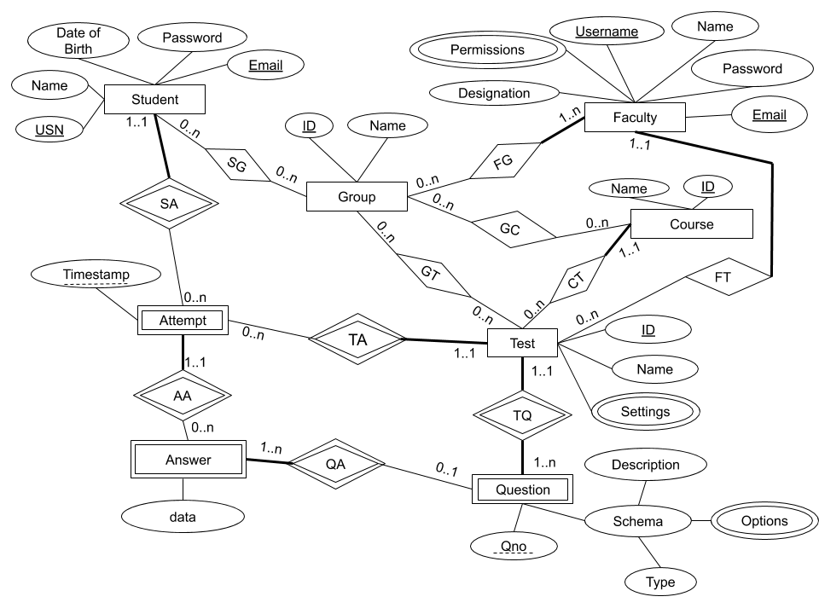

#### Entities

1. Administrator: represents a faculty that is able to perform privileged actions based on the permissions assigned
2. Student: represents a student
3. Group: represents a group of students and faculty
4. Course: represents a subject or a course
5. Test: represents a test or an examination
6. Question: represents a question in a test
7. Attempt: represents an attempt by a student to answer a test
8. Answer: represents an answer to a question given by the student in an attempt

#### Relationships

1. SG - A student can be present in 0-n groups. Each group can have 0-m students
2. FG - A faculty can be present in 0-n groups. Each group must have at least 1 faculty
3. GC - A group can have 0-n courses assigned to it. Each course can have 0-m groups that have it assigned to them
4. GT - A group can have 0-n test assigned to it. A test can have 0-m groups to which it is assigned
5. FT - A faculty can have 0-n tests which they can manage. A test can have 0-m faculties managing it
6. CT- A course can have multiple tests but a test must belong to only 1 course
7. TQ - A test has 0-n questions. A question can belong to only 1 test
8. SA - A student can have 0-n attempts to write tests. An attempt belongs to only 1 student
9. TA - A test can have 0-n attempts. An attempt belongs to only 1 test
10. AA - An attempt can have 0-n answers but an answer must belong to an attempt
11. QA - A question can have 0-n answers but an answer must belong to a question

### Database Structure

